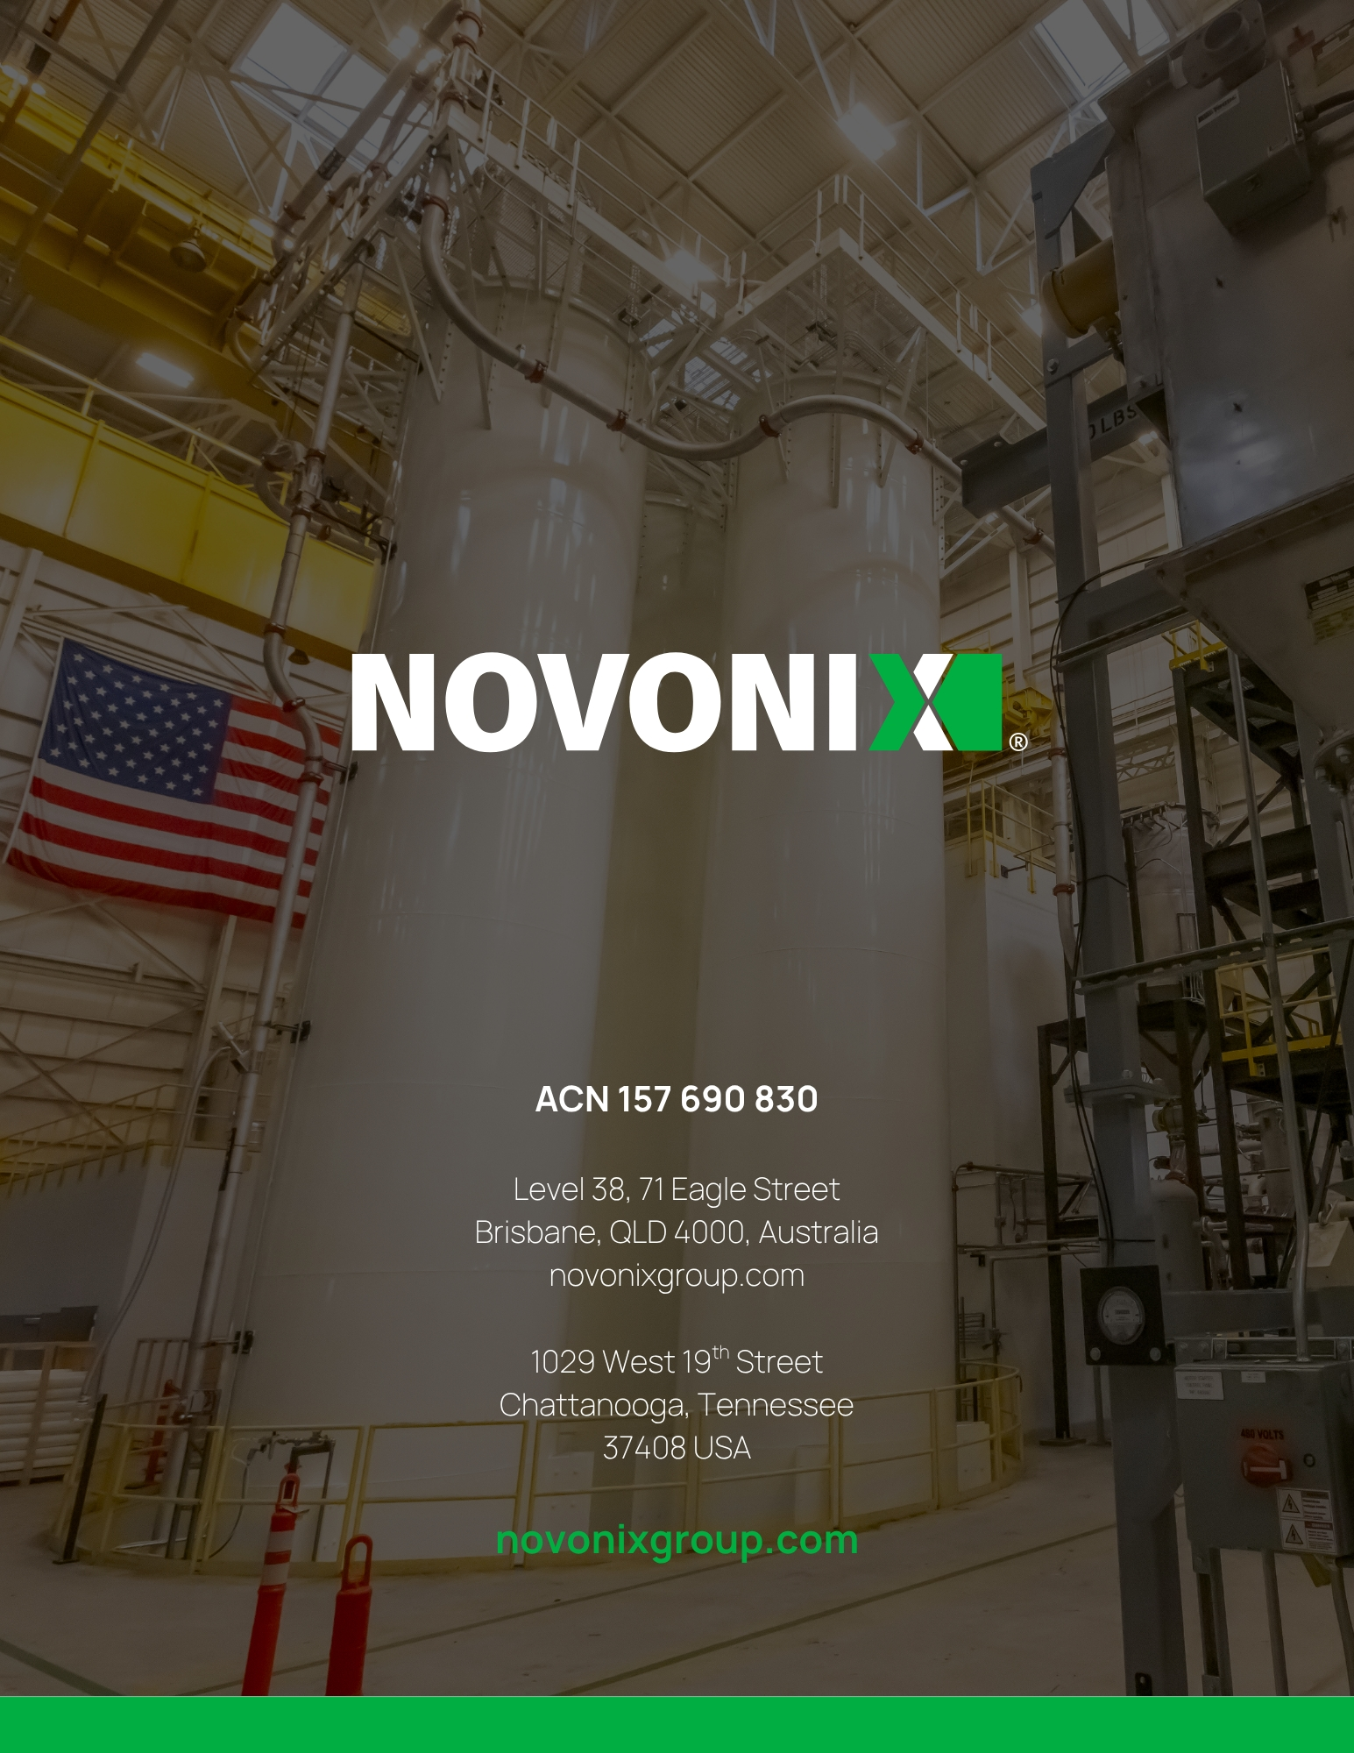
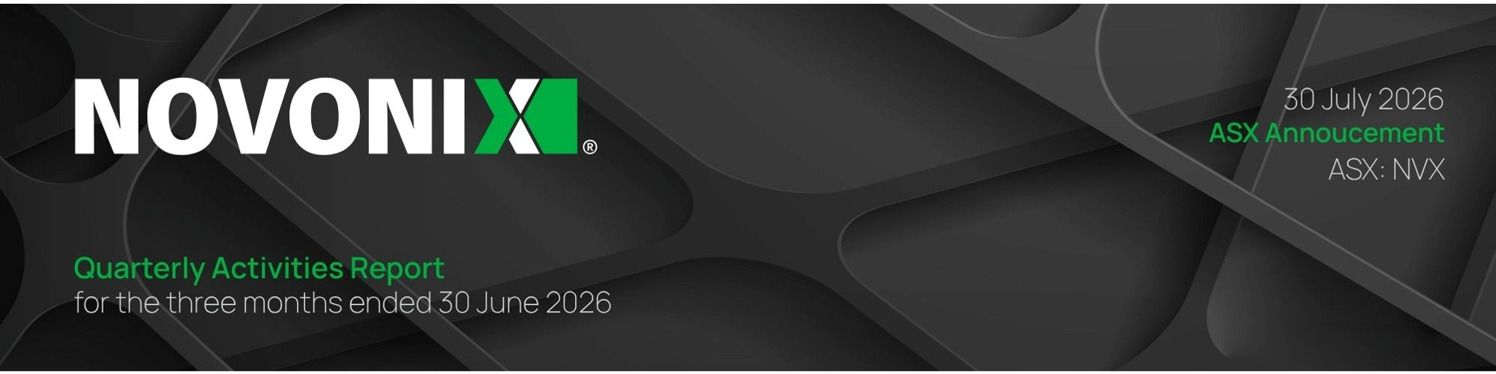

UNITED STATES
SECURITIES AND EXCHANGE COMMISSION

Washington, D.C. 20549

FORM 6-K

REPORT OF FOREIGN PRIVATE ISSUER PURSUANT TO RULE 13a-16 OR 15d-16 UNDER THE
SECURITIES EXCHANGE ACT OF 1934

For the month of July, 2026

001-41208
(Commission File Number)

NOVONIX LIMITED
(Translation of registrant’s name into English)

Level 38
71 Eagle Street
Brisbane, QLD 4000 Australia
(Address of principal executive office)

Indicate by check mark whether the registrant files or will file annual reports under cover of Form 20-F or Form 40-F.
Form 20-F ☒ Form 40-F ☐

Indicate by check mark if the registrant is submitting the Form 6-K in paper as permitted by Regulation S-T Rule 101(b)(1): ☐

Indicate by check mark if the registrant is submitting the Form 6-K in paper as permitted by Regulation S-T Rule 101(b)(7): ☐

EXHIBIT INDEX

Exhibit No. |  | Description
Exhibit 99.1 |  | ASX Announcement (Quarterly Activities/Appendix 4C Cash Flow Report) dated July 30, 2026

SIGNATURES

Pursuant to the requirements of the Securities Exchange Act of 1934, the registrant has duly caused this report to be signed on its behalf by the undersigned hereunto duly authorized.

NOVONIX LIMITED
By: |  | /s/ Mike O'Kronley
 |  | Mike O'Kronley
 |  | Chief Executive Officer

Date: July 30, 2026



Key Highlights
•
Panasonic C-sample Delivered: NOVONIX delivered a C-sample of synthetic graphite AAM to Panasonic Energy, with internal NOVONIX testing indicating it meets Panasonic’s specifications, subject to formal validation by Panasonic over the coming months.
•
Panasonic production timing reaffirmed: NOVONIX reaffirmed that it expects commencement of mass production for Panasonic to begin in the second half of 2027, subject to successful completion of the qualification process by Panasonic and its customers.
•
Successful Institutional Placement and SPP Launch: NOVONIX placed A$20.7 million with institutional and sophisticated investors and A$0.96 million with existing shareholders under its share purchase plan, each on the terms specified in the 17 June 2026 disclosure.
•
Trade Policy and Incentives: U.S. Government activity related to Section 301/232 investigations, section 842, the U.S. International Trade Commission, and implementation of 45X reflect strategic policy priorities and sustained attention of the U.S. Government on establishing a U.S. graphite AAM industry.
•
U.S. Senator Blackburn Tours Riverside Facility: On May 29, 2026, United States Senator from Tennessee Marsha Blackburn and members of her staff toured NOVONIX’s Riverside facility and publicly noted the importance of synthetic graphite to U.S. energy dominance and commented that it was great to see how NOVONIX is leading the way in Tennessee to ensure we can compete with China and protect our national security.
•
48C Certification: The U.S. Government certified the Riverside project in connection with the US$103 million tax credit previously allocated under the Section 48C Advanced Energy Project Credit Program.
•
Riverside Expansion Optionality: NOVONIX has decided not to proceed with the potential purchase of 17.5 acres adjacent to Riverside at this time but plans to maintain the ability to evaluate future opportunities with the property owners.
•
Board and CFO Transition: Ron Edmonds (previously Chief Accounting Officer for DOW Chemical) is serving as Interim Chief Financial Officer while NOVONIX conducts a search for a permanent CFO. Admiral Robert Natter has resumed the role of Chair during the interim period.

1029 West 19th Street, Chattanooga, Tennessee, USA, 37408 | novonixgroup.com | 1 | 

•
BTS Divestiture Completed: NOVONIX finalized and closed the sale of NOVONIX Battery Technology Solutions Inc. in Nova Scotia, Canada, to former Chief Executive Officer Dr. Chris Burns, effective 30 April 2026. BTS will operate independently through Avrion Battery Labs Inc. and Dryve Battery Materials Inc.

Select Details on Key Highlights

Panasonic C-Sample, Qualification Progress and Strategic Funding
NOVONIX’s delivery of a mass production qualification sample, or C-sample, of synthetic graphite anode active material to Panasonic Energy represented a critical commercialization milestone and provided the strategic backdrop for the Institutional Placement and Share Purchase Plan completed during the quarter. The capital raise followed strong market support for the Panasonic announcement and the Company’s progress toward what it believes is the first known synthetic graphite AAM C-sample produced in North America.
Proceeds from the raise are expected to support ongoing operations and be strategically deployed toward the capital expenditure and production-readiness activities required to keep NOVONIX aligned with its target of commencing commercial production for Panasonic in the second half of 2027. While the timing remains subject to successful completion of the broader qualification process by Panasonic and its customers, these investments are intended to support capacity, equipment, and operational readiness to meet start of production for Panasonic.

U.S. Government Policy Environment
Continued Focus on Building a Domestic Graphite Supply Chain
The Company continues to engage constructively with the U.S. Government regarding policies and actions intended to strengthen domestic critical mineral processing and reduce reliance on foreign supply chains for battery materials. Over the past year, multiple U.S. Government agencies have undertaken reviews and initiatives to address market distortions affecting the U.S. graphite anode active material ("AAM") industry. While the timing and outcome of these processes remain uncertain, collectively they represent a significant level of attention to the strategic importance of establishing a domestic graphite AAM industry.
These policies and actions reflect the U.S. Government's continued recognition that establishing a U.S. graphite AAM industry is an important national security objective and that additional trade and market measures may be required to support investment in U.S. production capacity. These policies and actions are occurring alongside broader discussions regarding the use of tariffs,

1029 West 19th Street, Chattanooga, Tennessee, USA, 37408 | novonixgroup.com | 2

procurement preferences, domestic content requirements, and other trade policy tools to encourage investment in U.S. processing capacity.
The Administration has also indicated that future trade negotiations may be used to reinforce secure and resilient critical mineral supply chains with trusted partners. The Company continues to evaluate all available legal and policy options to support the development of a competitive domestic graphite AAM industry.
Ongoing Trade and National Security Reviews
Section 301 Investigations
The Office of the United States Trade Representative ("USTR") has completed its investigation under Section 301 of the U.S. Trade Act of 1974 (“Section 301”) relating to forced labor and has imposed 10%-12.5% tariffs on most goods, including synthetic graphite, imported from the 59 countries (including China and Indonesia) and the European Union targeted in the investigation.
USTR is currently conducting another investigation under Section 301structural excess manufacturing capacity and production in strategically important sectors. The excess capacity investigation is targeting 16 countries and the European Union. This investigation is evaluating whether additional trade measures, including tariffs on imports from the target countries, are warranted to address market distortions that may adversely affect U.S. manufacturers, including producers of battery materials.
Section 232 Investigations
Separately, the U.S. Department of Commerce (“Commerce”) has completed its investigation pursuant to Section 232 of the U.S. Trade Expansion Act of 1962, into imports of processed critical minerals and their derivative products. Commerce concluded that such imports are entering the United States in quantities and under circumstances that threaten to impair U.S. national security, and the President concurred with that determination. In response, on 14 January 2026, the President issued a Proclamation (the “232 Proclamation”) directing the Secretary of Commerce and the U.S. Trade Representative to negotiate agreements with trading partners to address these national security concerns. The 232 Proclamation specifically contemplates the negotiation of measures such as price floors for trade in processed critical minerals.
Under the President's 232 Proclamation, the Secretary of Commerce and the U.S. Trade Representative were required to provide the President with an update on the status of negotiations with trading partners within 180 days, which was 13 July 2026. No public

1029 West 19th Street, Chattanooga, Tennessee, USA, 37408 | novonixgroup.com | 3

announcement has been made regarding that report. The 232 Proclamation provides that, if satisfactory agreements are not reached or prove ineffective, the Administration may implement additional import adjustment measures, including tariffs, minimum import prices, or other remedies available under Section 232.
Section 842 Requirements
Section 842 of the U.S. National Defense Authorization Act for Fiscal Year 2026 (NDAA) establishes phased sourcing requirements for advanced batteries procured by the U.S. Department of Defense. Beginning with new acquisition programs in 2028, the Department generally may procure only advanced batteries and battery cells whose functional cell components and technology are not owned, sourced, refined, or produced by a foreign entity of concern ("FEOC”). The statute provides a limited exception where final assembly occurs outside an FEOC, more than 95% of the cost of the functional cell components is attributable to non-FEOC sources, and the battery is produced without FEOC-licensed technology. The requirements expand to standard batteries in 2029 and existing acquisition programs in 2031.
The Company and others in the U.S. battery materials industry have been working closely with Department of Defense personnel on implementing regulations to ensure that the interests of the U.S. domestic graphite AAM industry are properly addressed.
Treasury Implementation of Section 45X
The U.S. Department of the Treasury (“Treasury”) continues to develop regulations and administrative guidance relating to the U.S. Internal Revenue Code Section 45X Advanced Manufacturing Production Tax Credit (“45X Tax Credit”).
The 45X Tax Credit provides, among other things, a production tax credit to manufacturers of battery cells equal to US$35 per kilowatt-hour of battery cell capacity for qualifying battery cells manufactured in the United States and sold to an unrelated party. To be eligible for the credit, qualifying battery cells must satisfy increasing requirements limiting material assistance from prohibited foreign entities. These requirements are measured by reference to the proportion of direct material and production costs attributable to non-prohibited foreign entity sources. For battery cells sold in 2027, the required amount is 65%, increasing each year to a maximum of 85% in 2030 and thereafter. Under current law, the credit is scheduled to be reduced by 25% in 2030, by 50% in 2031 and by 75% in 2032 before expiring for battery cells after 2032.
Industry participants, including the Company, have encouraged Treasury to improve the effectiveness of the credit for domestic graphite AAM production. Suggestions include revisions

1029 West 19th Street, Chattanooga, Tennessee, USA, 37408 | novonixgroup.com | 4

to the applicable material cost ratio ("MACR") tables and related methodologies, clarification of the definitions of "Prohibited Foreign Entity" ("PFE") and related ownership and control concepts, clarifications regarding eligibility of previously acquired or contracted material, and measures to reduce opportunities for circumvention of the statutory intent.
Industry participants have also advocated for the establishment of product-specific Harmonized Tariff Schedule ("HTS") classifications for graphite anode active material to improve transparency, support more effective trade enforcement, and facilitate the administration of U.S. incentive programs.
U.S. International Trade Commission
Five individuals have been confirmed by the Senate as new Commissioners of the U.S. International Trade Commission ("ITC"). These appointments have substantially changed the composition of the Commission.
The Company's prior antidumping and countervailing duty ("AD/CVD") petition against China was ultimately unsuccessful following a split decision (2-1) by the ITC on the question of material retardation. The two Commissioners who voted against the petition have been replaced with the new Commissioners. With its full complement of six Commissioners, only three affirmative votes are required for the Commission to reach a positive determination for U.S. industry.
Potential Future Trade Actions
The Company continues to evaluate all available legal and policy options to support the development of a competitive domestic graphite AAM industry. Subject to market conditions and the evolution of the relevant factual record, the Company intends to consider filing a new AD/CVD petition at an appropriate time.

Divestiture of Battery Technology Solutions
NOVONIX completed the divestiture of its Battery Technology Solutions (BTS) division to further enhance its strategic focus on synthetic graphite production and reduce the ongoing funding requirements associated with BTS’s business.
The transaction reflected a broader effort to align capital, management attention, and operational resources with the Company’s core product strategy of scaling North American synthetic graphite AAM production. While BTS had valuable technology and capabilities, it was outside NOVONIX’s primary commercial focus and represented a strategic distraction from the Company’s highest-priority customer qualification, production readiness, and commercialization activities.

1029 West 19th Street, Chattanooga, Tennessee, USA, 37408 | novonixgroup.com | 5

This focus is also supported by the Company’s September 2025 sale of its Mount Dromedary mining rights in Northern Queensland, which further streamlined the portfolio and reinforced NOVONIX’s strategic emphasis on its core synthetic graphite AAM business.
Financial Overview
Cash Balance
The Company’s cash balance as of 30 June 2026 was US$59.5 million.
Payments to Related Parties
A total of US$281,000 was paid to Directors and their associates for salary and wages, director fees, and superannuation during the quarter ended 30 June 2026.
Capital Expenditures
The Company invested US$2.2 million in property, plant, and equipment during the quarter ended 30 June 2026, primarily for production assets at its Riverside facility in Chattanooga, Tennessee. The Company is engaged with CMEI (formerly MESC) in connection with its review of the grant and continues to comply with all requests from CMEI.

This announcement has been authorized for release by NOVONIX Chairman,
Admiral Robert J. Natter, USN Ret.

About NOVONIX
NOVONIX strives to reduce supply chain risk, support U.S. energy independence, and establish a resilient battery materials supply chain. The company is building a North American platform for critical battery materials at its Chattanooga, Tennessee headquarters and anode materials operations. NOVONIX is positioned as a supplier of advanced battery materials and technologies powering the energy storage and electrification economy.
To learn more, visit www.novonixgroup.com or follow us on LinkedIn and X.
For NOVONIX Limited
Investors: ir@novonixgroup.com
Media: media@novonixgroup.com

1029 West 19th Street, Chattanooga, Tennessee, USA, 37408 | novonixgroup.com | 6

Cautionary Note Regarding Forward-Looking Statements
This report contains forward-looking statements about the Company and the industry in which it operates. Forward-looking statements can generally be identified by use of words such as “anticipate,” “believe,” “contemplate,” “continue,” “could,” “estimate,” “expect,” “intend,” “may,” “plan,” “potential,” “predict,” “project,” “should,” “target,” “will,” or “would,” or other similar expressions. Examples of forward-looking statements in this report include, among others, statements made regarding: anticipated qualification, production and shipping timelines; anticipated validation of samples and completion of any qualification process; progress and timing of scaling and commencement of commercial production at the Riverside facility; anticipated potential offtake, supply, and other agreements or revisions thereto; potential future expansion of Riverside or the purchase of other property; the recruitment or hiring of a new CFO; how BTS will operate going forward; expectations for use of the proceeds from the Institutional Placement and Share Purchase Plan; the impacts of economic uncertainty, tariffs, duties, and other legislation on the timely achievement of targets and customer milestones; the intent, effects and timing of government policies, regulations, tariffs, duties, and other measures and the potential benefits thereof; certain entities’ supply or future supply to the U.S. Market; ability to obtain or maintain and benefit from additional government funding, tax credits, and other support; potential changes to tax credit, tariff, or other programs; the outcome, impact or benefit of ongoing or additional trade investigations and negotiations; our participation in legal or policy measures in the future; and efforts to help localize and strengthen the battery supply chain for critical materials and play a leading role in the transition to cleaner energy solutions and long-term energy security.
The Company has based such statements on current expectations and projections about future events and trends that it believes may affect its financial condition, results of operations, business strategy and financial needs. Such forward-looking statements involve and are subject to known and unknown risks, uncertainties and other factors which may cause actual results, performance or achievements to be materially different from any future results, performance or achievements expressed or implied by the forward-looking statements. Such factors include, among others, the timely deployment and scaling of its furnace technology, ability to meet the technical specifications and demand of existing and future customers, the accuracy of estimates regarding market size, expenses, future revenue, capital requirements, its needs and access to additional financing, the availability and impact and compliance with the applicable terms of government funding and other support, the ability to obtain patent rights effective to protect its technologies and processes and successfully defend any challenges to such rights and prevent others from commercializing such technologies and processes, and legal and regulatory developments in the United States, Australia, and other jurisdictions. These and other factors that could affect its business and results are included in its filings with the U.S. Securities and Exchange Commission (“SEC”), including the Company’s most recent annual report on Form 20-F. Copies of these filings

1029 West 19th Street, Chattanooga, Tennessee, USA, 37408 | novonixgroup.com | 7

may be obtained by visiting the Company’s Investor Relations website at www.novonixgroup.com or the SEC's website at www.sec.gov.
Forward-looking statements are not guarantees of future performance or outcomes, and actual performance and outcomes may differ materially from those made in or suggested by the forward-looking statements contained in this report. Accordingly, recipients of this report should not place undue reliance on forward-looking statements. Any forward-looking statement in this report is based only on information currently available to us and speaks only as of the date on which it is made. The Company undertakes no obligation to update any forward-looking statement, whether written or oral, that may be made from time to time, whether as a result of new information, future developments or otherwise, except as required by law.
Industry and Market Data
This Report contains estimates and information concerning the Company’s industry and business, including estimated market share in the markets for its products. Unless otherwise expressly stated, the Company obtained this industry, business, market, and other information from reports, research surveys, studies, and similar data prepared by third parties, industry, general publications, government data, and similar sources. This Report also includes certain information and data that is derived from internal research. While the Company’s believes that its internal research is reliable, such research has not been verified by any third party.
Estimates and information concerning the Company’s industry and business involve a number of assumptions and limitations. Although the Company is responsible for all the disclosures contained in this Report and it believes the third-party market position, market opportunity, and market size data included in this Report are reliable, it has not independently verified the accuracy or completeness of this third-party data. Information that is based on projections, assumptions, and estimates of future performance and the future performance of the industry in which it operates is necessarily subject to a high degree of uncertainty and risk due to a variety of factors, which could cause results to differ materially from those expressed in these publications and report.

1029 West 19th Street, Chattanooga, Tennessee, USA, 37408 | novonixgroup.com | 8

Appendix 4C
Quarterly cash flow report for entities
subject to Listing Rule 4.7B
Name of entity
NOVONIX LIMITED
ABN |  | Quarter ended (“current quarter”)
54 157 690 830 |  | 30 June 2026

Consolidated statement of cash flows |  | Current quarter $USD’000 | Year to date  (6 months)  $USD’000
1. | Cash flows from operating activities | 429 | 2,121
1.1 | Receipts from customers | 429 | 2,121
1.2 | Payments for | (2,156) | (4,505)
 | (a)  research and development | (2,156) | (4,505)
 | (b)  product manufacturing and operating costs | (251) | (1,001)
 | (c)  advertising and marketing | (53) | (110)
 | (d)  leased assets | - | -
 | (e)  staff costs | (4,937) | (12,769)
 | (f)  administration and corporate costs | (1,616) | (6,814)
1.3 | Dividends received (see note 3) | - | -
1.4 | Interest received | 255 | 597
1.5 | Interest and other costs of finance paid | (320) | (759)
1.6 | Income taxes paid | - | -
1.7 | Government grants and tax incentives | 7 | 185
1.8 | Other (provide details if material) | - | -
1.9 | Net cash from / (used in) operating activities | (8,642) | (23,055)

ASX Listing Rules Appendix 4C (17/07/20)
+ See chapter 19 of the ASX Listing Rules for defined terms

Consolidated statement of cash flows |  | Current quarter $USD’000 | Year to date  (6 months)  $USD’000
2. | Cash flows from investing activities | - | -
2.1 | Payments to acquire or for: | - | -
 | (a)  entities | - | -
 | (b) businesses | - | -
 | (c) property, plant and equipment | (2,260) | (9,030)
 | (d) investments | - | -
 | (e) intellectual property | - | -
 | (f) other non-current assets | - | -
2.2 | Proceeds from disposal of: | - | -
 | (a)  entities | - | -
 | (b) businesses | - | -
 | (c) property, plant and equipment | - | -
 | (d) investments | - | -
 | (e) intellectual property | - | -
 | (f) other non-current assets | - | -
2.3 | Cash flows from loans to other entities | - | -
2.4 | Dividends received (see note 3) | - | -
2.5 | Other:  – Refunds / (payments for security deposits) | 863 | 55
 | - Cash and cash equivalents disposed of | (1,044) | (1,044)
2.6 | Net cash from / (used in) investing activities | (2,441) | (10,019)
3. | Cash flows from financing activities | 14,515 | 14,515
3.1 | Proceeds from issues of equity securities (excluding convertible debt securities) | 14,515 | 14,515
3.2 | Proceeds from issue of convertible debt securities | - | -
3.3 | Proceeds from exercise of options | - | -

ASX Listing Rules Appendix 4C (17/07/20)
+ See chapter 19 of the ASX Listing Rules for defined terms

Consolidated statement of cash flows |  | Current quarter $USD’000 | Year to date  (6 months)  $USD’000
3.4 | Transaction costs related to issues of equity securities or convertible debt securities | (794) | (815)
3.5 | Proceeds from borrowings | - | -
3.6 | Repayment of borrowings | (188) | (531)
3.7 | Transaction costs related to loans and borrowings
3.8 | Dividends paid
3.9 | Other (provide details if material) | (307) | (906)
3.10 | Net cash from / (used in) financing activities | 13,226 | 12,263
4. | Net increase / (decrease) in cash and cash equivalents for the period | 57,149 | 79,866
4.1 | Cash and cash equivalents at beginning of period | 57,149 | 79,866
4.2 | Net cash from / (used in) operating activities (item 1.9 above) | (8,642) | (23,055)
4.3 | Net cash from / (used in) investing activities (item 2.6 above) | (2,441) | (10,019)
4.4 | Net cash from / (used in) financing activities (item 3.10 above) | 13,226 | 12,263
4.5 | Effect of movement in exchange rates on cash held | 243 | 480
4.6 | Cash and cash equivalents at end of period | 59,535 | 59,535

ASX Listing Rules Appendix 4C (17/07/20)
+ See chapter 19 of the ASX Listing Rules for defined terms

5. | Reconciliation of cash and cash equivalents  at the end of the quarter (as shown in the consolidated statement of cash flows) to the related items in the accounts | Current quarter  $USD’000 | Previous quarter  $USD’000
5.1 | Bank balances | 59,535 | 57,149
5.2 | Call deposits | - | -
5.3 | Bank overdrafts | - | -
5.4 | Other (provide details) | - | -
5.5 | Cash and cash equivalents at end of quarter (should equal item 4.6 above) | 59,535 | 57,149

ASX Listing Rules Appendix 4C (17/07/20)
+ See chapter 19 of the ASX Listing Rules for defined terms

6. | Payments to related parties of the entity and their associates |  | Current quarter  $USD'000
6.1 | Aggregate amount of payments to related parties and their associates included in item 1 |  | 281
6.2 | Aggregate amount of payments to related parties and their associates included in item 2 |  | -
Note: if any amounts are shown in items 6.1 or 6.2, your quarterly activity report must include a description of, and an explanation for, such payments.

Payments to related parties includes director fees, salary and wages, and superannuation.

7. | Financing facilities  Note: the term “facility’ includes all forms of financing arrangements available to the entity.  Add notes as necessary for an understanding of the sources of finance available to the entity. | Total facility amount at quarter end  $USD’000 | Amount drawn at quarter end  $USD’000
7.1 | Loan facilities | 30,100 | 30,100
7.2 | Credit standby arrangements | - | -
7.3 | Other (please specify) –  Convertible debentures | 35,000 | 35,000
7.4 | Total financing facilities | 65,100 | 65,100
7.5 | Unused financing facilities available at quarter end |  | -
7.6 | Include in the box below a description of each facility above, including the lender, interest rate, maturity date and whether it is secured or unsecured. If any additional financing facilities have been entered into or are proposed to be entered into after quarter end, include a note providing details of those facilities as well.

ASX Listing Rules Appendix 4C (17/07/20)
+ See chapter 19 of the ASX Listing Rules for defined terms

•
On 28 October 2025, the Company entered into a Funding Agreement for an additional drawdown of US$40,000,000, net of a 5% discount, of unsecured convertible debentures issued to Yorkville Advisors Global LP. Interest rate is 5% and the debentures are convertible at the holder’s election (refer to ASX Announcement of 28 October 2025). The debentures were fully drawn at 30 June 2026.
•
On 28 July 2021, the Group purchased commercial land and buildings in Chattanooga for USD $42.6M to expand the NAM business. The Group entered into a loan facility with PNC Real Estate to purchase the land and buildings. The total available amount under the facility is USD$30,100,000 and it has been fully drawn down as of 30 June 2026. The facility is repayable in monthly instalments, commencing September 2021 and ending August 2031. The land and buildings have been pledged as security for the loan.

8. | Estimated cash available for future operating activities | $USD’000
8.1 | Net cash from / (used in) operating activities (item 1.9) | (8,642)
8.2 | Cash and cash equivalents at quarter end (item 4.6) | 59,535
8.3 | Unused finance facilities available at quarter end (item 7.5) | -
8.4 | Total available funding (item 8.2 + item 8.3) | 59,535
8.5 | Estimated quarters of funding available (item 8.4 divided by item 8.1) | 6.9
8.5 | Note: if the entity has reported positive net operating cash flows in item 1.9, answer item 8.5 as “N/A”. Otherwise, a figure for the estimated quarters of funding available must be included in item 8.5.
8.6 | If item 8.5 is less than 2 quarters, please provide answers to the following questions:
 | 8.6.1 Does the entity expect that it will continue to have the current level of net operating cash flows for the time being and, if not, why not?
 | Answer: N/A
 | 8.6.2 Has the entity taken any steps, or does it propose to take any steps, to raise further cash to fund its operations and, if so, what are those steps and how likely does it believe that they will be successful?
 | Answer: N/A

ASX Listing Rules Appendix 4C (17/07/20)
+ See chapter 19 of the ASX Listing Rules for defined terms

8.6.3 Does the entity expect to be able to continue its operations and to meet its business objectives and, if so, on what basis?
Answer: N/A

Note: where item 8.5 is less than 2 quarters, all of questions 8.6.1, 8.6.2 and 8.6.3 above must be answered.

Compliance statement
1 This statement has been prepared in accordance with accounting standards and policies which comply with Listing Rule 19.11A.
2 This statement gives a true and fair view of the matters disclosed.

Date: | 30 July 2026
Authorised by: | By the Chairman of the Board
 | (Name of body or officer authorising release – see note 4)

ASX Listing Rules Appendix 4C (17/07/20)
+ See chapter 19 of the ASX Listing Rules for defined terms

Notes
1. This quarterly cash flow report and the accompanying activity report provide a basis for informing the market about the entity’s activities for the past quarter, how they have been financed and the effect this has had on its cash position. An entity that wishes to disclose additional information over and above the minimum required under the Listing Rules is encouraged to do so.
2. If this quarterly cash flow report has been prepared in accordance with Australian Accounting Standards, the definitions in, and provisions of, AASB 107: Statement of Cash Flows apply to this report. If this quarterly cash flow report has been prepared in accordance with other accounting standards agreed by ASX pursuant to Listing Rule 19.11A, the corresponding equivalent standard applies to this report.
3. Dividends received may be classified either as cash flows from operating activities or cash flows from investing activities, depending on the accounting policy of the entity.
4. If this report has been authorised for release to the market by your board of directors, you can insert here: “By the board”. If it has been authorised for release to the market by a committee of your board of directors, you can insert here: “By the [name of board committee – e.g. Audit and Risk Committee]”. If it has been authorised for release to the market by a disclosure committee, you can insert here: “By the Disclosure Committee”.
5. If this report has been authorised for release to the market by your board of directors and you wish to hold yourself out as complying with recommendation 4.2 of the ASX Corporate Governance Council’s Corporate Governance Principles and Recommendations, the board should have received a declaration from its CEO and CFO that, in their opinion, the financial records of the entity have been properly maintained, that this report complies with the appropriate accounting standards and gives a true and fair view of the cash flows of the entity, and that their opinion has been formed on the basis of a sound system of risk management and internal control which is operating effectively.

ASX Listing Rules Appendix 4C (17/07/20)
+ See chapter 19 of the ASX Listing Rules for defined terms

ASX Listing Rules Appendix 4C (17/07/20)
+ See chapter 19 of the ASX Listing Rules for defined terms

