UNITED STATES

SECURITIES AND EXCHANGE COMMISSION

Washington, D.C. 20549

FORM 6-K

REPORT OF FOREIGN PRIVATE ISSUER PURSUANT TO RULE 13a-16 OR 15d-16 UNDER THE SECURITIES EXCHANGE ACT OF 1934

For the month of October, 2026

001-41208

(Commission File Number)

NOVONIX LIMITED

(Translation of registrant’s name into English)

Level 38

71 Eagle Street

Brisbane, QLD 4000 Australia

(Address of principal executive office)

Indicate by check mark whether the registrant files or will file annual reports under cover of Form 20‑F or Form 40‑F. Form 20-F ☒ Form 40-F ☐

Indicate by check mark if the registrant is submitting the Form 6-K in paper as permitted by Regulation S-T Rule 101(b)(1): ☐

Indicate by check mark if the registrant is submitting the Form 6-K in paper as permitted by Regulation S-T Rule 101(b)(7): ☐

EXHIBIT INDEX

Exhibit No. Description

Exhibit 99.1 ASX Announcement (Quarterly Activities/Appendix 4C Cash Flow Report) dated October 30, 2026

SIGNATURES

Pursuant to the requirements of the Securities Exchange Act of 1934, the registrant has duly caused this report to be signed on its behalf by the undersigned hereunto duly authorized.

NOVONIX LIMITED

By: /s/ Mike O'Kronley

Mike O'Kronley

Chief Executive Officer

Date: October 30, 2026

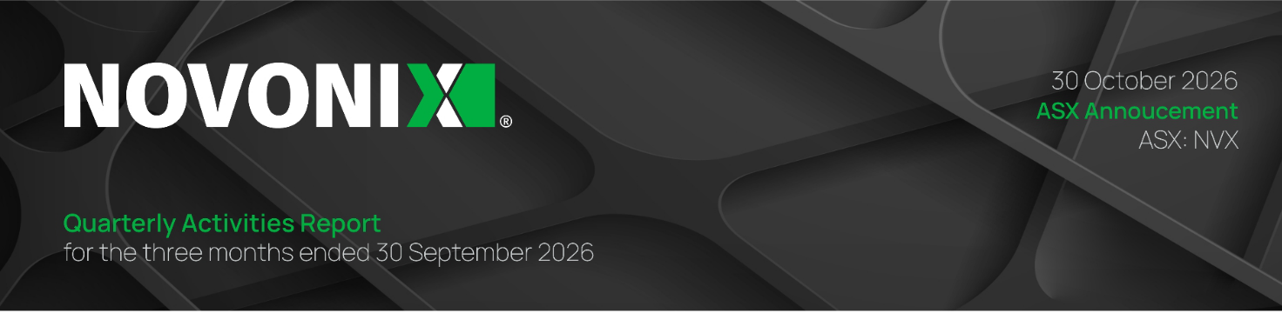

Exhibit 99.1

Key Highlights

- South Korea–U.S. Initiative: NOVONIX was selected for presentation under a government-led infrastructure initiative connecting U.S. projects with Korean industrial and financing participants; selection does not constitute a funding commitment.

- Domestic Precursor Collaboration: NOVONIX and ACP Technologies entered into a non-binding MOU to pursue the development of domestically-sourced, pitch-coated synthetic graphite active anode material (AAM) and advance mass-production processes, supporting the development of a fully domestic AAM supply chain.

- Riverside Commercialization: NOVONIX continues to engage with a variety of companies across the battery supply chain to validate NOVONIX materials, while internally focusing on process improvement, production readiness, and disciplined deployment of capital.

- Customer Qualification: NOVONIX is continuing with process development improvements aimed at ensuring all customer product qualification requirements can be met. NOVONIX believes that the outstanding items in material specification will be addressed in the near future.

- Amortization Event: In September, NOVONIX disclosed an amortization event under its Yorkville convertible debenture arrangement arising from the share-price condition. As required under that arrangement, a US$7 million repayment occurred from cash reserves in each of September and October.

- ISO 9001 Certification: In October, NOVONIX announced that its Riverside facility in Chattanooga, Tennessee, achieved ISO 9001:2015 certification, an internationally recognized standard for quality management systems.

Strategic Partnerships and Financing Engagement

In September, NOVONIX announced that the first phase of the NOVONIX synthetic graphite AAM project had been included in a South Korea–U.S. infrastructure initiative coordinated by the Republic of Korea’s Ministry of Land, Infrastructure and Transport and Korea Overseas Infrastructure & Urban Development Corporation (KIND). The initiative facilitates introductions to Korean contractors, strategic partners, and potential financing sources.

NOVONIX also announced a non-binding memorandum of understanding with ACP Technologies to evaluate domestic carbon precursor materials and pitch-coated synthetic graphite AAM.
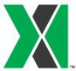

1029 West 19th Street, Chattanooga, Tennessee, USA, 37408 | novonixgroup.com | 1

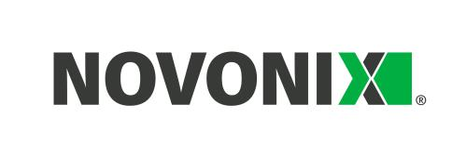
Proposed work includes product development, process validation, and potential customer sampling. Any commercial arrangements remain subject to further agreement.

Commercial Operations and Customer Qualification

During the quarter, NOVONIX continued its qualification work for synthetic graphite anode active material produced at its Riverside facility in Chattanooga, Tennessee. As disclosed in September, the initial C-sample met most specification parameters, leaving several outstanding. NOVONIX has identified targeted actions and is undertaking further work to address the remaining parameters in coordination with the customer’s final acceptance. It is expected that all outstanding work will be completed in the near future. Successful qualification remains subject to further customer testing and approval. The Company’s previously communicated expectation for commencement of mass production sales in the second half of 2027 remains subject to successful completion of the applicable qualification process and other operational and commercial conditions.

Industry and Sector Outlook

Graphite AAM is a critical input to lithium-ion batteries used in stationary energy storage, defense applications, and electric vehicles. Demand for battery energy storage in the United States continues to grow, supported by increasing electricity demand, grid reliability requirements, and the expansion of energy storage infrastructure.

According to the U.S. Energy Information Administration (EIA), U.S. utility-scale battery storage capacity reached approximately 52 gigawatts (GW) by June 2026, with developers
planning to add approximately 54 GW of additional capacity through 2028.¹ This growth represents an expanding potential domestic market for battery materials, including synthetic graphite AAM.

Industry outlooks are consistent with the EIA data. A September 2026 report by the Solar Energy Industries Association (SEIA) and Benchmark Mineral Intelligence revised its forecast
for cumulative U.S. energy storage capacity through 2030 upward by 11.5% to 683 GWh,² reflecting stronger-than-expected demand. The report also noted that U.S. energy storage installations reached a record 20.2GWh in the second quarter of 2026.

U.S. Government Policy Developments

National Security Focus
U.S. government policy continues to emphasize the importance of secure domestic critical mineral and battery supply chains. During the quarter, the U.S. Government continued to advance

- U.S. Energy Information Administration, “Battery storage capacity averaged 70% growth over the last three years,” Today in Energy, August 7, 2026, https://www.eia.gov/TodayinEnergy/detail.php?id=67925
² SEIA and Benchmark Mineral Intelligence, U.S. Energy Storage Market Outlook Q3 2026, September 1, 2026. Supporting report.

1029 West 19th Street, Chattanooga, Tennessee, USA, 37408 | novonixgroup.com | 2

policies aimed at strengthening domestic critical minerals and battery materials supply chains and reducing reliance on foreign-controlled sources. On July 20, 2026, the President issued an Executive Order, Securing America's Defense Supply Chains and Ensuring Domestic Acquisition of Critical Materials, establishing a policy of sourcing critical materials and components for military equipment domestically or from allied nations. The Executive Order directs the Department of War to strengthen supply chain traceability, address reliance on unreliable foreign suppliers, and accelerate the qualification of alternative sources of critical materials and components.

These initiatives complement existing measures that, beginning on October 1, 2027, prohibit the Department of War from procuring batteries produced by six specified Chinese manufacturers, including Contemporary Amperex Technology Co., Limited (CATL) and BYD Company Limited (BYD), subject to waiver by the Secretary of War. The restrictions also apply to batteries that have a majority of components from those manufacturers and batteries manufactured or assembled by those entities.

Beginning in January 2028, these restrictions will expand to prohibit, in a phased manner, the use of battery materials sourced from foreign entities of concern (FEOCs), such as China.

These prohibitions reflect the U.S. government's increasing focus on reducing reliance on Chinese-controlled battery supply chains for defense applications and reinforces the strategic importance of developing secure domestic sources of critical battery materials, including graphite AAM.

AD/CVD Appeal

The March 2026 determination by the U.S. International Trade Commission (ITC) that imports of graphite AAM from China did not materially retard the establishment of a domestic industry is under appeal before the U.S. Court of International Trade (CIT). Oral arguments are scheduled for the second half of January 2027.

If the CIT identifies legal errors or findings unsupported by substantial evidence, it will remand the determination to the ITC for reconsideration. On remand, the ITC would be required to address the issues identified by the CIT. The ITC could either reaffirm its original negative determination or reach a new affirmative determination. An affirmative determination would result in the imposition of antidumping and countervailing duties on Chinese graphite AAM at the rates previously determined by the U.S. Department of Commerce, which were approximately 160%.

ITC reversals are unusual. However, of the three commissioners who issued the original decision against the domestic industry, in March 2026, only one (who voted in favor of the domestic industry and imposing the tariffs) remains on the ITC. There are now five new commissioners on the ITC. With a full slate of six commissioners, only three commissioners need to vote in favor of the domestic industry to have the tariffs imposed.

1029 West 19th Street, Chattanooga, Tennessee, USA, 37408 | novonixgroup.com | 3

On October 19, 2026, the petitioners in the appeal requested that the ITC request a voluntary remand of their March 2026 negative injury determination. It would be unusual for the ITC to request such a voluntary remand. However, if they do so, and if the CIT grants such request, the review of the appeal would be expedited.

Funding and Financial Overview

Cash Balance

The Company’s cash balance as of 30 September 2026 was US$33.652 million.

Payments to Related Parties

A total of US$339,000 was paid to Directors and their associates for salary and wages, director fees, and superannuation during the quarter ended 30 September 2026.

Capital Expenditures

The Company invested US$8.36 million in property, plant, and equipment during the quarter ended 30 September 2026, primarily for production assets at its Riverside facility in Chattanooga, Tennessee.

The Company continues to assess capital requirements and funding alternatives to support production readiness and future capacity. Funding remains subject to applicable conditions, commercial agreements, and capital-market and government-program availability. In September, the Company disclosed an amortisation event under its Yorkville convertible debenture arrangement arising from the share-price condition. As required under that arrangement, a US$7 million repayment occurred from cash reserves in each of September and October.

Events Subsequent to Quarter End

ISO 9001 Certification

In October 2026, NOVONIX announced that its Riverside facility in Chattanooga, Tennessee, achieved ISO 9001:2015 certification, an internationally recognized standard for quality management systems. The certification follows an independent assessment of the facility's quality management processes and demonstrates that NOVONIX has established systems designed to support consistent product quality, process control, traceability, continuous improvement, and customer satisfaction.

Achieving ISO 9001 certification represents an important milestone in NOVONIX's progression toward commercial-scale production of synthetic graphite anode active material. The certification strengthens the Company's quality management infrastructure and supports its ability to meet the rigorous requirements of automotive battery manufacturers and other customers. It also represents an important step in NOVONIX's broader commercialization

1029 West 19th Street, Chattanooga, Tennessee, USA, 37408 | novonixgroup.com | 4

strategy as the Company advances customer qualification activities and prepares for future production at Riverside.

The certification does not itself constitute customer product qualification, which remains subject to each customer's applicable testing and approval requirements.

PowerCo Supply Agreement

In October 2026, NOVONIX and PowerCo SE entered into an Amended and Restated Supply Framework Agreement, replacing the previous binding offtake agreement. The revised agreement reflects evolving market conditions and PowerCo's updated production plans for its battery manufacturing facility in St. Thomas, Ontario, where commencement of production has been deferred from 2027 to 2029. Under the revised framework, the parties have removed the previous volume, pricing, and delivery commitments and intend to negotiate new commercial terms following completion of PowerCo's qualification process and required certifications. The agreement maintains the parties' commercial relationship while providing flexibility to align future supply arrangements with PowerCo's revised production schedule and market demand.

Outlook

In the near term, the Company's priorities remain focused on advancing customer qualification and developing synthetic graphite AAM to address evolving customer requirements across the energy storage systems (ESS) and electric vehicle markets. Building on the momentum of its recent ISO 9001 certification, the Company continues to advance facility readiness, strengthen quality systems, and refine manufacturing operations to support consistent product deliveries at commercial scale. Alongside these operational priorities, cost discipline and strategic financing remain central to the Company's financial strategy, with continued efforts to optimize operating expenses and engagement with institutional investors and strategic financing partners to strengthen its balance sheet and support its next stage of commercial growth. The Company also continues to engage with the U.S. Government on policy initiatives aimed at strengthening the domestic AAM industry and supporting a competitive environment for U.S.-based synthetic graphite AAM production.

About NOVONIX

NOVONIX strives to reduce supply chain risk, support U.S. energy independence, and establish a resilient battery materials supply chain. The company is building a North American platform for critical battery materials at its Chattanooga, Tennessee headquarters and anode materials operations. NOVONIX is positioned as a supplier of advanced battery materials and technologies powering the energy storage and electrification economy.

1029 West 19th Street, Chattanooga, Tennessee, USA, 37408 | novonixgroup.com | 5

To learn more, visit www.novonixgroup.com or follow us on LinkedIn and X.

For NOVONIX Limited
Investors: ir@novonixgroup.com
Media: media@novonixgroup.com

Authorization and Disclaimers

This announcement has been authorized for release by NOVONIX Chairman, Admiral Robert J. Natter, USN Ret.

Cautionary Note Regarding Forward-Looking Statements

This report contains forward-looking statements about the Company and the industry in which it operates. Forward-looking statements can generally be identified by use of words such as “anticipate,” “believe,” “contemplate,” “continue,” “could,” “estimate,” “expect,” “intend,” “may,” “plan,” “potential,” “predict,” “project,” “should,” “target,” “will,” or “would,” or other similar expressions. Examples of forward-looking statements in this report include, among others, statements made regarding: anticipated sample submission, qualification, production and shipping timelines; anticipated validation of samples and completion of any qualification process; progress and timing of scaling and commencement of commercial production at the Riverside facility; anticipated potential offtake, supply, development, and other agreements or revisions thereto; the potential benefits or impacts of current or future ISO certifications; amortization events or the funding thereof; the impacts of economic uncertainty, tariffs, duties, and other legislation on the timely achievement of targets and customer milestones; the intent, effects and timing of government policies, regulations, tariffs, duties, and other measures and the potential benefits thereof; certain entities’ supply or future supply to the U.S. Market; ability to obtain or maintain and benefit from additional government funding, tax credits, and other support (both foreign and domestic); potential changes to tax credit, tariff, or other programs; the outcome, impact or benefit of ongoing or additional trade investigations and negotiations; our participation in legal or policy measures in the future; anticipated market growth and capacity demands; our market position in general; and efforts to help localize and strengthen the battery supply chain for critical materials and play a leading role in the transition to cleaner energy solutions and long-term energy security.

The Company has based such statements on current expectations and projections about future events and trends that it believes may affect its financial condition, results of operations, business strategy and financial needs. Such forward-looking statements involve and are subject to known and unknown risks, uncertainties and other factors which may cause actual results, performance or achievements to be materially different from any future results, performance or

1029 West 19th Street, Chattanooga, Tennessee, USA, 37408 | novonixgroup.com | 6

achievements expressed or implied by the forward-looking statements. Such factors include, among others, the timely deployment and scaling of its furnace technology, ability to meet the technical specifications and demand of existing and future customers, the accuracy of estimates regarding market size, expenses, future revenue, capital requirements, its needs and access to additional financing, the availability and impact and compliance with the applicable terms of government funding and other support, the ability to obtain patent rights effective to protect its technologies and processes and successfully defend any challenges to such rights and prevent others from commercializing such technologies and processes, and legal and regulatory developments in the United States, Australia, and other jurisdictions. These and other factors that could affect its business and results are included in its filings with the U.S. Securities and Exchange Commission (“SEC”), including the Company’s most recent annual report on Form 20-F. Copies of these filings may be obtained by visiting the Company’s Investor Relations website at www.novonixgroup.com or the SEC's website at www.sec.gov.

Forward-looking statements are not guarantees of future performance or outcomes, and actual performance and outcomes may differ materially from those made in or suggested by the forward-looking statements contained in this report. Accordingly, recipients of this report should not place undue reliance on forward-looking statements. Any forward-looking statement in this report is based only on information currently available to us and speaks only as of the date on which it is made. The Company undertakes no obligation to update any forward-looking statement, whether written or oral, that may be made from time to time, whether as a result of new information, future developments or otherwise, except as required by law.

Industry and Market Data

This Report contains estimates and information concerning the Company’s industry and business, including estimated market share in the markets for its products. Unless otherwise expressly stated, the Company obtained this industry, business, market, and other information from reports, research surveys, studies, and similar data prepared by third parties, industry, general publications, government data, and similar sources. This Report also includes certain information and data that is derived from internal research. While the Company’s believes that its internal research is reliable, such research has not been verified by any third party.

Estimates and information concerning the Company’s industry and business involve a number of assumptions and limitations. Although the Company is responsible for all the disclosures contained in this Report and it believes the third-party market position, market opportunity, and market size data included in this Report are reliable, it has not independently verified the accuracy or completeness of this third-party data. Information that is based on projections,

1029 West 19th Street, Chattanooga, Tennessee, USA, 37408 | novonixgroup.com | 7

assumptions, and estimates of future performance and the future performance of the industry in which it operates is necessarily subject to a high degree of uncertainty and risk due to a variety of factors, which could cause results to differ materially from those expressed in these publications and report.

1029 West 19th Street, Chattanooga, Tennessee, USA, 37408 | novonixgroup.com | 8

Appendix 4C

Quarterly cash flow report for entities

subject to Listing Rule 4.7B

Name of entity

NOVONIX LIMITED

ABN |  |  |  |  | Quarter ended (“current quarter”)
54 157 690 830 |  |  |  |  | 30 September 2026
 |  |  |  |  | Current quarter | Year to date
Consolidated statement of cash flows |  |  |  |  | Current quarter | (9 months)
 |  |  |  |  | $USD’000 | (9 months)
 |  |  |  |  | $USD’000 | $USD’000
1. | Cash flows from operating activities
1.1 | Receipts from customers |  |  |  | 582 | 2,703
1.2 | Payments for
 | (a) | research and development |  |  | (2,064) | (6,569)
 | (b) | product manufacturing and |  |  | - | (1,001)
 |  | operating costs
 | (c) advertising and marketing |  |  |  | (31) | (141)
 | (d) leased assets |  |  |  | - | -
 | (e) staff costs |  |  |  | (3,553) | (16,322)
 | (f) administration and corporate costs |  |  |  | (4,429) | (11,243)
1.3 | Dividends received (see note 3) |  |  |  | - | -
1.4 | Interest received |  |  |  | 185 | 782
1.5 | Interest and other costs of finance paid |  |  |  | (455) | (1,214)
1.6 | Income taxes paid |  |  |  | - | -
1.7 | Government grants and tax incentives |  |  |  | - | 185
1.8 | Other (provide details if material) |  |  |  | - | -
1.9 | Net cash from / (used in) operating |  |  |  | (9,765) | (32,820)
 | activities

1029 West 19th Street, Chattanooga, Tennessee, USA, 37408 | novonixgroup.com | 9

 | Current quarter | Year to date
Consolidated statement of cash flows | Current quarter | (9 months)
Consolidated statement of cash flows | $USD’000 | (9 months)
 | $USD’000 | $USD’000

- Cash flows from investing activities

2.1 Payments to acquire or for:

 | (a) | entities | - | -
 | (b) | businesses | - | -
 | (c) | property, plant and equipment | (8,360) | (17,390)
 | (d) | investments | - | -
 | (e) | intellectual property | - | -
 | (f) | other non-current assets | - | -
2.2 | Proceeds from disposal of:
 | (a) | entities | - | -
 | (b) | businesses | - | -
 | (c) | property, plant and equipment | - | -
 | (d) | investments | - | -
 | (e) | intellectual property | - | -
 | (f) | other non-current assets | - | -
2.3 | Cash flows from loans to other entities |  | - | -
2.4 | Dividends received (see note 3) |  | - | -
2.5 | Other: |  | (809) | (754)
 | – Refunds / (payments for security |  | (809) | (754)
 | deposits)
 | - Cash and cash equivalents disposed of |  | - | (1,044)
2.6 | Net cash from / (used in) investing |  | (9,169) | (19,188)
 | activities
3. | Cash flows from financing activities
3.1 | Proceeds from issues of equity securities
 | (excluding convertible debt securities) |  | 675 | 15,190
3.2 | Proceeds from issue of convertible debt |  | - | -
 | securities
3.3 | Proceeds from exercise of options |  | - | -

1029 West 19th Street, Chattanooga, Tennessee, USA, 37408 | novonixgroup.com | 10

 |  | Current quarter | Year to date
Consolidated statement of cash flows |  | Current quarter | (9 months)
 |  | $USD’000 | (9 months)
 |  | $USD’000 | $USD’000
3.4 | Transaction costs related to issues of | (58) | (873)
 | equity securities or convertible debt
 | securities
3.5 | Proceeds from borrowings | - | -
3.6 | Repayment of borrowings | (7,274) | (7,805)
3.7 | Transaction costs related to loans and
 | borrowings
3.8 | Dividends paid
3.9 | Other (provide details if material) | (172) | (1,078)
3.10 | Net cash from / (used in) financing | (6,829) | 5,434
 | activities
4. | Net increase / (decrease) in cash and
 | cash equivalents for the period
4.1 | Cash and cash equivalents at beginning
 | of period | 59,535 | 79,866
4.2 | Net cash from / (used in) operating | (9,765) | (32,820)
 | activities (item 1.9 above)
4.3 | Net cash from / (used in) investing | (9,169) | (19,188)
 | activities (item 2.6 above)
4.4 | Net cash from / (used in) financing | (6,829) | 5,434
 | activities (item 3.10 above)
4.5 | Effect of movement in exchange rates on | (120) | 360
 | cash held
4.6 | Cash and cash equivalents at end of | 33,652 | 33,652
 | period

1029 West 19th Street, Chattanooga, Tennessee, USA, 37408 | novonixgroup.com | 11

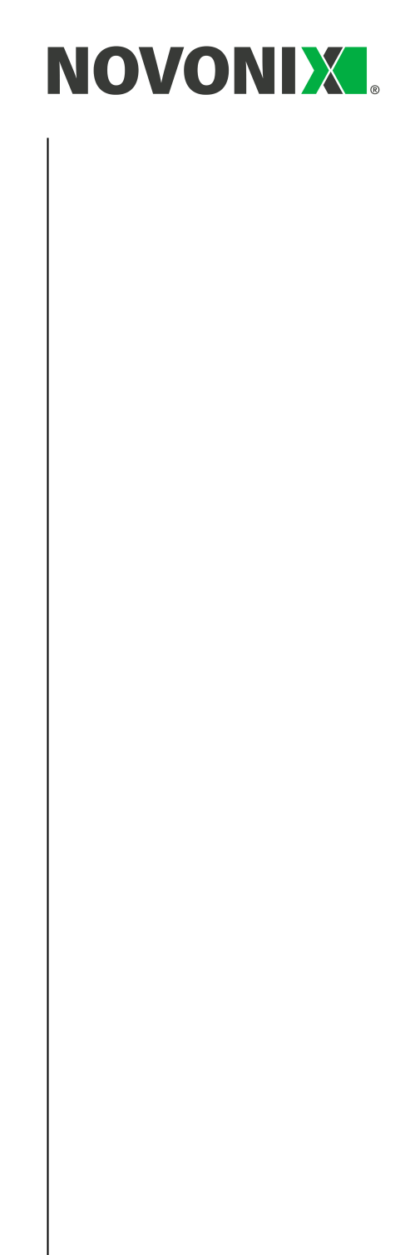
5. | Reconciliation of cash and cash | Current quarter |  | Previous quarter
 | equivalents | $USD’000 |  | $USD’000
 | at the end of the quarter (as shown in
 | the consolidated statement of cash
 | flows) to the related items in the
 | accounts
5.1 | Bank balances | 33,652 |  | 59,535
5.2 | Call deposits | - |  | -
5.3 | Bank overdrafts | - |  | -
5.4 | Other (provide details) | - |  | -
5.5 | Cash and cash equivalents at end of
5.5 | Cash and cash equivalents at end of | 33,652 |  | 59,535
 | quarter (should equal item 4.6 above)
6. | Payments to related parties of the entity and their associates |  |  | Current quarter
 |  |  |  | $USD'000
6.1 | Aggregate amount of payments to related parties and their |  |  | 339
 | associates included in item 1
6.2 | Aggregate amount of payments to related parties and their |  |  | -
 | associates included in item 2

Note: if any amounts are shown in items 6.1 or 6.2, your quarterly activity report must include a description of, and an explanation for, such payments.

Payments to related parties includes director fees, salary and wages, and superannuation.

7. | Financing facilities | Total facility amount at | Amount drawn at
 | Note: the term “facility’ includes all forms | quarter end | quarter end
 | of financing arrangements available to | $USD’000 | $USD’000
 | the entity.
 | Add notes as necessary for an
 | understanding of the sources of finance
 | available to the entity.
7.1 | Loan facilities | 30,100 | 30,100
7.2 | Credit standby arrangements | - | -
7.3 | Other (please specify) –
 | Convertible debentures | 28,000 | 28,000
 | Total financing facilities
7.4 | Total financing facilities | 58,100 | 58,100
7.5 | Unused financing facilities available at quarter end |  | -

1029 West 19th Street, Chattanooga, Tennessee, USA, 37408 | novonixgroup.com | 12

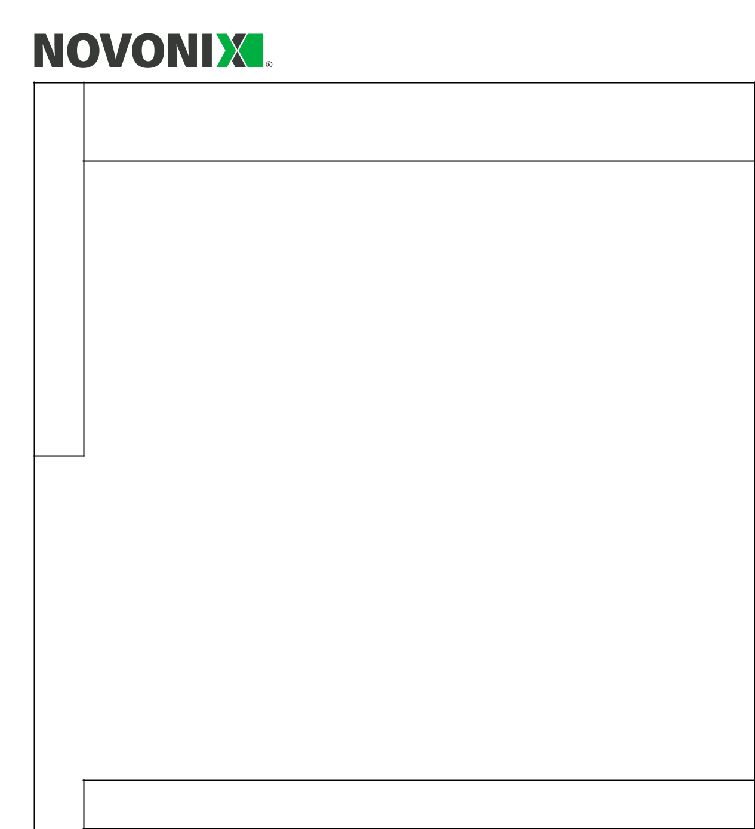
7.6 Include in the box below a description of each facility above, including the lender, interest rate, maturity date and whether it is secured or unsecured. If any additional financing facilities have been entered into or are proposed to be entered into after quarter end, include a note providing details of those facilities as well.

- On 28 October 2025, the Company entered into a Funding Agreement for an additional drawdown of US$40,000,000, net of a 5% discount, of unsecured convertible debentures issued to Yorkville Advisors Global LP. Interest rate is 5% and the debentures are convertible at the holder’s election (refer to ASX Announcement of 28 October 2025). The debentures were fully drawn at 30 September 2026. During the quarter, an Amortisation Event occurred under the Funding Agreement and the Company redeemed debentures with a face value of US$7,000,000 by cash payment (refer to ASX Announcement of 10 September 2026). The face value of debentures outstanding at 30 September 2026 was US$28,000,000.

- On 28 July 2021, the Group purchased commercial land and buildings in Chattanooga for USD $42.6M to expand the NAM business. The Group entered into a loan facility with PNC Real Estate to purchase the land and buildings. The total available amount under the facility is USD$30,100,000 and it has been fully drawn down as of 30 September 2026. The facility is repayable in monthly instalments, commencing September 2021 and ending August 2031. The land and buildings have been pledged as security for the loan.

8. | Estimated cash available for future operating activities | $USD’000
8.1 | Net cash from / (used in) operating activities (item 1.9) | (9,765)
8.2 | Cash and cash equivalents at quarter end (item 4.6) | 33,652
8.3 | Unused finance facilities available at quarter end (item 7.5) | -
8.4 | Total available funding (item 8.2 + item 8.3) | 33,652

8.5 | Estimated quarters of funding available (item 8.4 divided by |  | 3.4
 | item 8.1) |  | 3.4
 | Note: if the entity has reported positive net operating cash flows in item 1.9, answer item 8.5
 | as “N/A”. Otherwise, a figure for the estimated quarters of funding available must be included
 | in item 8.5.
8.6 | If item 8.5 is less than 2 quarters, please provide answers to the following questions:
 | 8.6.1 Does the entity expect that it will continue to have the current level of net operating
 | cash flows for the time being and, if not, why not?

Answer: N/A

1029 West 19th Street, Chattanooga, Tennessee, USA, 37408 | novonixgroup.com | 13

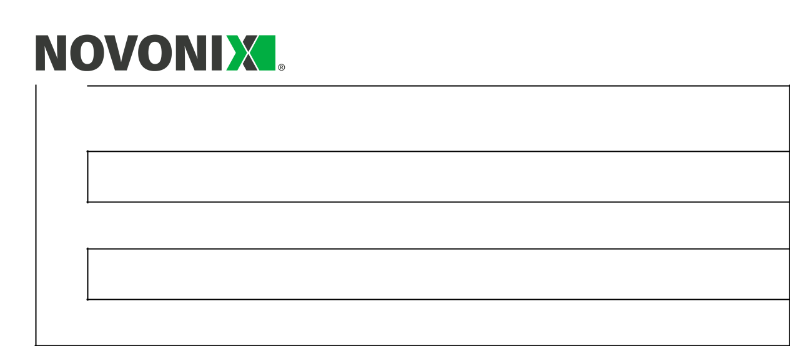
8.6.2 Has the entity taken any steps, or does it propose to take any steps, to raise further cash to fund its operations and, if so, what are those steps and how likely does it believe that they will be successful?

Answer: N/A

8.6.3 Does the entity expect to be able to continue its operations and to meet its business objectives and, if so, on what basis?

Answer: N/A

Note: where item 8.5 is less than 2 quarters, all of questions 8.6.1, 8.6.2 and 8.6.3 above must be answered.

Compliance statement

- This statement has been prepared in accordance with accounting standards and policies which comply with Listing Rule 19.11A.

- This statement gives a true and fair view of the matters disclosed.

Date: 30 October 2026

Authorised by: By the Chairman of the Board

(Name of body or officer authorising release – see note 4)

1029 West 19th Street, Chattanooga, Tennessee, USA, 37408 | novonixgroup.com | 14

Notes

- This quarterly cash flow report and the accompanying activity report provide a basis for informing the market about the entity’s activities for the past quarter, how they have been financed and the effect this has had on its cash position. An entity that wishes to disclose additional information over and above the minimum required under the Listing Rules is encouraged to do so.

- If this quarterly cash flow report has been prepared in accordance with Australian Accounting Standards, the definitions in, and provisions of, AASB 107: Statement of Cash Flows apply to this report. If this quarterly cash flow report has been prepared in accordance with other accounting standards agreed by ASX pursuant to Listing Rule 19.11A, the corresponding equivalent standard applies to this report.

- Dividends received may be classified either as cash flows from operating activities or cash flows from investing activities, depending on the accounting policy of the entity.

- If this report has been authorised for release to the market by your board of directors, you can insert here: “By the board”. If it has been authorised for release to the market by a committee of your board of directors, you can insert here: “By the [name of board committee – e.g. Audit and Risk Committee]”. If it has been authorised for release to the market by a disclosure committee, you can insert here: “By the Disclosure Committee”.

- If this report has been authorised for release to the market by your board of directors and you wish to hold yourself out as complying with recommendation 4.2 of the ASX Corporate Governance Council’s Corporate Governance Principles and Recommendations, the board should have received a declaration from its CEO and CFO that, in their opinion, the financial records of the entity have been properly maintained, that this report complies with the appropriate accounting standards and gives a true and fair view of the cash flows of the entity, and that their opinion has been formed on the basis of a sound system of risk management and internal control which is operating effectively.

1029 West 19th Street, Chattanooga, Tennessee, USA, 37408 | novonixgroup.com | 15

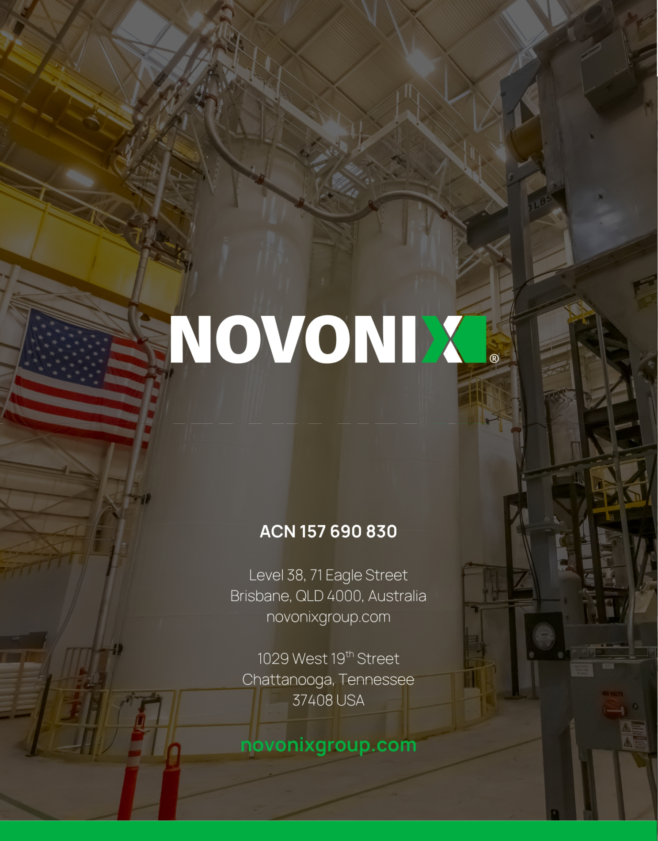

1029 West 19th Street, Chattanooga, Tennessee, USA, 37408 | novonixgroup.com | 16

1029 West 19th Street, Chattanooga, Tennessee, USA, 37408 | novonixgroup.com | 17

ASX Listing Rules Appendix 4C (17/07/20)

+ See chapter 19 of the ASX Listing Rules for defined terms

